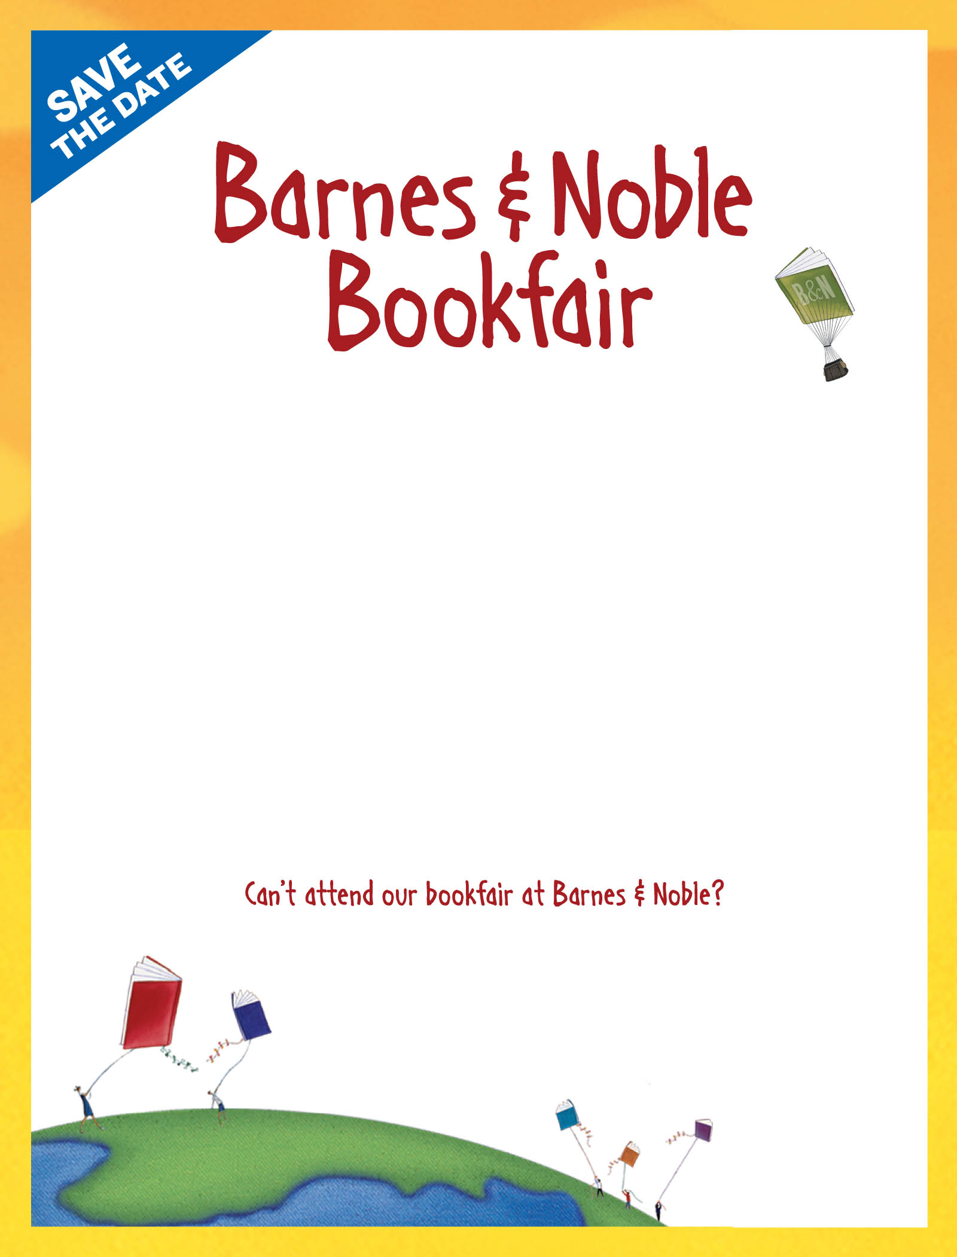

San Antonio Romance Authors

ro
Barnes & Noble La Cantera
Saturday, Feb. 14th, 3:00 PM
Support SARA and stock up on your Romance titles for Valentine’s Day!
Stop by and purchase new books by:
D’Ann Burrow, Laurie Olerich, Angela Smith,
Andrea Stehle and Teri Wilson!

If you shop in the store on this date in the café, music/dvd department, NOOK dept., or in Books – make sure to give this flyer to the cashier, or let them know you are with SARA. A percentage of your sale will benefit our organization!
Visit bn.com/bookfairs to support us online from 02/14/15 to 02/19/15
by entering Bookfair ID 11553351 at checkout.

A percentage of your Barnes & Noble purchases
will benefit our school/organization.

